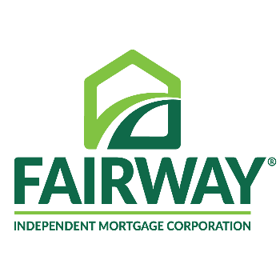
Contact: George Bain 303-818-9977
gbain@fairwaymc.com
Provider: Fairway Independent Mortgage Corporation

Intermediate Title: Reverse Mortgages: The Cinderella of Retirement Planning? – 1 Hour

Description: Financial advisors have long looked at Reverse Mortgages as the "Loan of Last Resort"-- the ugly stepsister of the retirement planning story. This workshop will create a major paradigm shift in your thinking. The instructor explains how recent program changes and groundbreaking research by the financial planning industry and noted academics have overwhelmingly proven the necessity of using reverse mortgages at the age of 62, not 82. With 10,000 Baby Boomers turning 62 daily and over $6 trillion in Home Equity amongst your senior clients, reverse mortgages just may be the late coming Cinderella to the retirement ball that fixes the retirement crisis we are facing.
Learning Objectives: The course will be covering How a Reverse Mortgage can reduce tax obligations, decrease Sequence of Returns Risk, increase Portfolio Survivability, and effects your Retirement Income Efficiency

Course Outline:
INTRO TO REVERSE MORTGAGES (5 Mins)
- About Us
- Ask Yourself
- Perfect Storm Statistics
- Projected Changes in Population

REVERSE MORTGAGE REQUIREMENTS (10 Mins)
A. Reverse Mortgage Basics
B. Reverse Mortgage Benefits
C. Payment Plans
STRATEGIES OF USING A REVERSE MORTGAGE (20 Mins)
- The 3 buckets & The Sacred Cow of Home Equity
- Reverse Mortgage Safety
- The Reverse mortgage Line of Credit (LOC) Growth
- The Coordintated Strategy
ADDITIONAL USES OF A REVERSE MORTGAGE (10 Mins)
- Shield Home Equity
- Long Term Care
- Life Insurance
- Health Insurance
- Tax Planning
HOW TO USE A REVERSE MORTGAGE RECAP (10 Mins)
- Recent Changes
- Planning Ahead for Younger Clients
- High-Need Clients
- How To Use A Reverse Mortgage
QUESTIONS AND ANSWERS (5 Mins)
Total (60 Mins)

